Notes

1. I need an easy way for “estimators” (evaluators) to access the interface and just open according the ID, and not be able to change another one. Now any evaluator can open other different of his, is very good for the administrator, I like it a lot, but the evaluators should only open according the ID.
2. The headers don’t allow to filter data, just order.



1. It must not able to assign negative values



In this case when the -10 is selected must assign 0

If -10 is selected the others can’t be selected



1. When the Estimation is open for edition, the information is different.

The data shown in list is changed, I think some fields are initialized with first of the list, and not the info that was entered before when was defined and saved.

For example, if I select an Estimation from the list, take a look of info from the list.

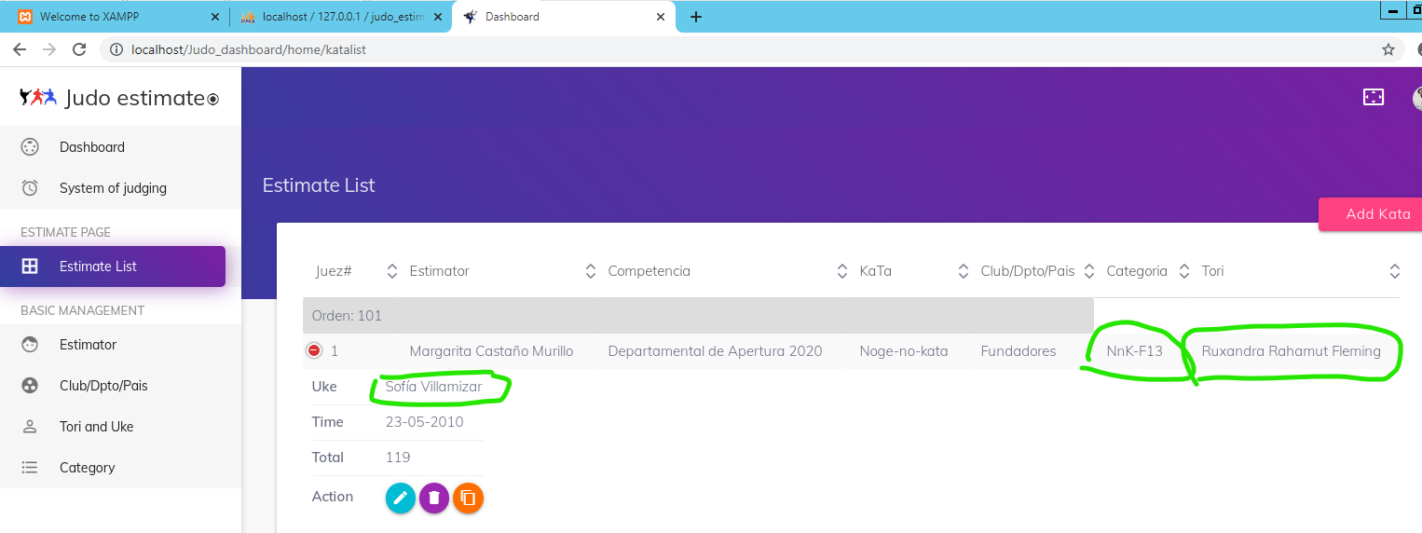

When the Edit Estimation is open, see how the info changes and is different from the list.

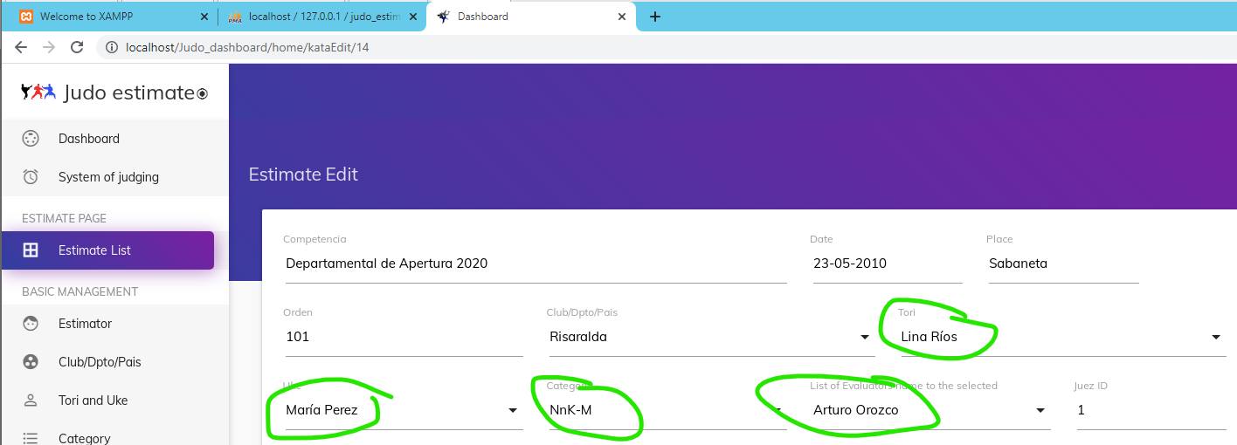

1. Can you add a field for ID?

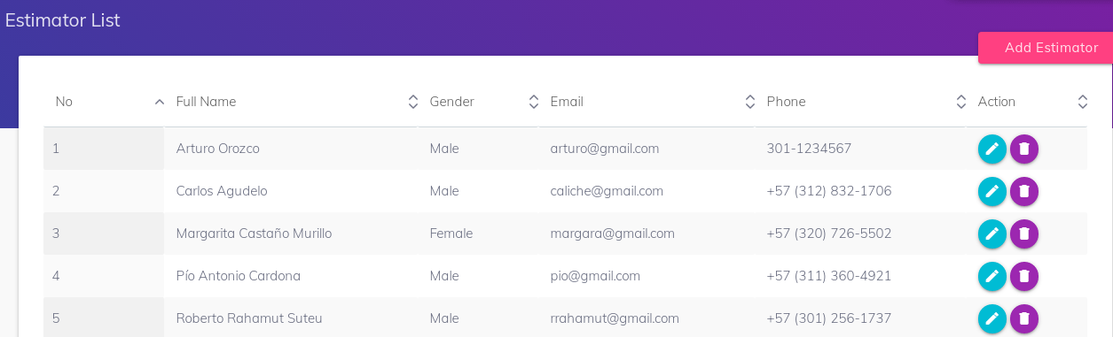

1. The + and – only works one time, if there is selected the second time, doesn’t work.

The sequence I used was + - + or - + -

The second +/- doesn’t add/subtract

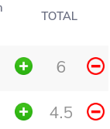

1. The formula for the calculation by technique shouldn’t be AVG (T1 … T5) it should

SUM (T1 … T5) - MAX (T1 … T5) – MIN (T1 … T5)

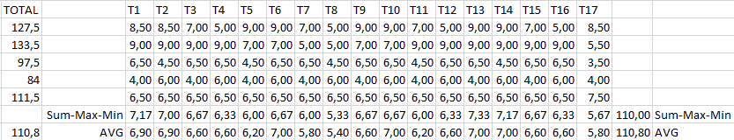

I looked up into the Judging.php but I couldn’t find the calculation in order to adjust the formula

$query[$key] = array_merge($value, $query2[0], $query3[0]);

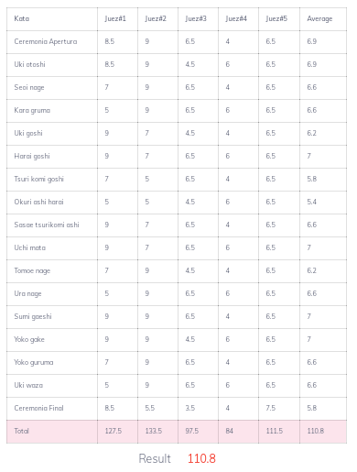It should be 110.0

|  |  |
| --- | --- |
|  | T1 |
|  | 8.5 |
|  | ~~_9 _~~ |
|  | 6.5 |
|  | ~~_4_~~ |
|  | 6.5 |
| Sum | 8.5+6.5+6.5=21.5 |
| -Max | -9 |
| -Min | -4 |
| (Sum-Max-Min)/3 | 7.17 |

1. Continuing with System if Judging, when a technique has a row with all judges, the final score should be divided by 2

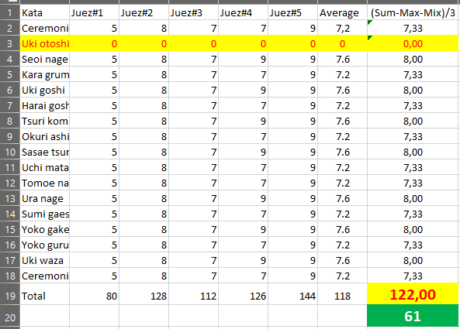

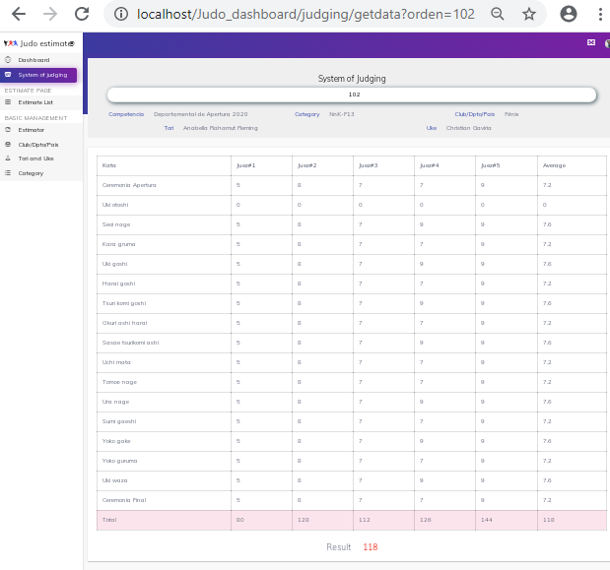

1. I think it would be nice to have a way to save the final results, in order to show them on the widgets.

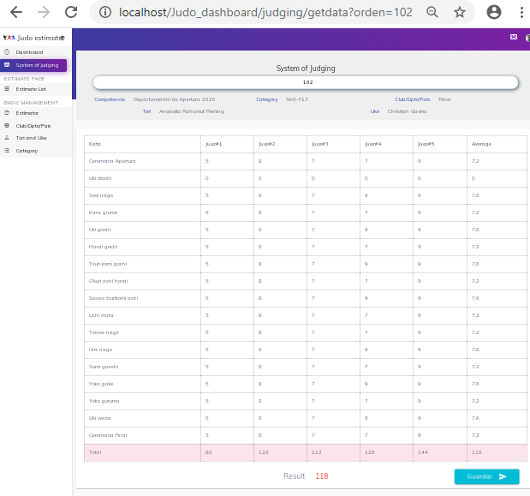

1. In the Dashboard the icondon’t do anything.

Would be useful if is possible to move it or else can configure the widgets?

For example, it should be possible to select the couple already evaluated so from other widgets to count the errors and points.

1. In the Dashboard the Widget for “Current Competition” not show the column for Results values and the order grouped by Categories

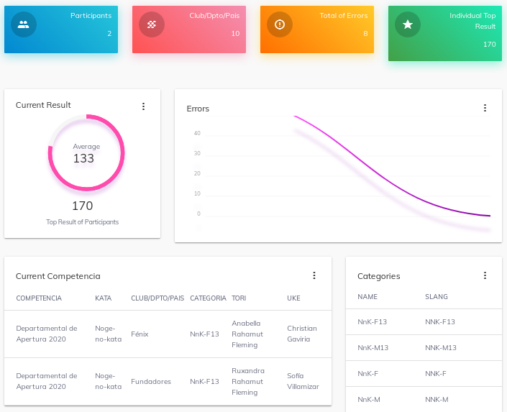

1. Is possible to have the option to clear all checks, like clean the slide option, in order to initialize the board, asking if is sure to erase all the errors selected.

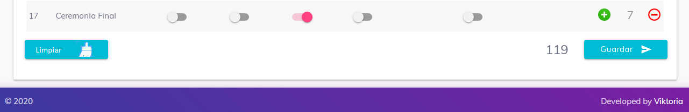

1. In general, I think it would be nice to have a sort of hand-off in order to be able of doing some adjustments.